Replacing a Damaged myIRB Approval Stamp

- Remove the invalid stamp, if one exists.
Note: If no stamp appears, skip to “2. Copy a valid stamp” on page 2.

Open your source file (the one containing the stamp myIRB couldn’t accept). Next, open the header for editing by left clicking twice or right clicking once then selecting Edit Header (A) when it appears.
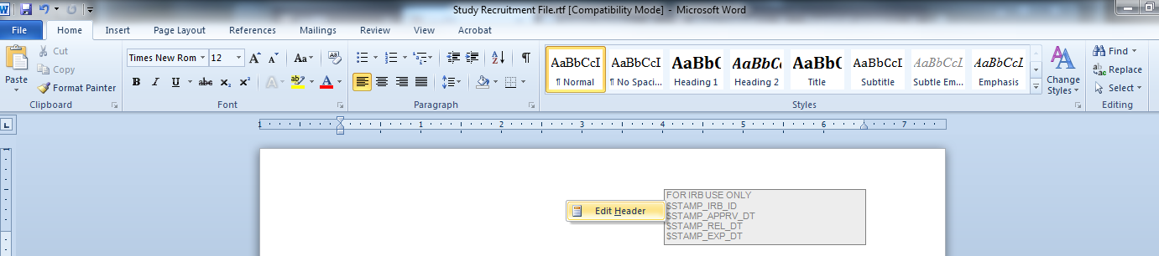

A

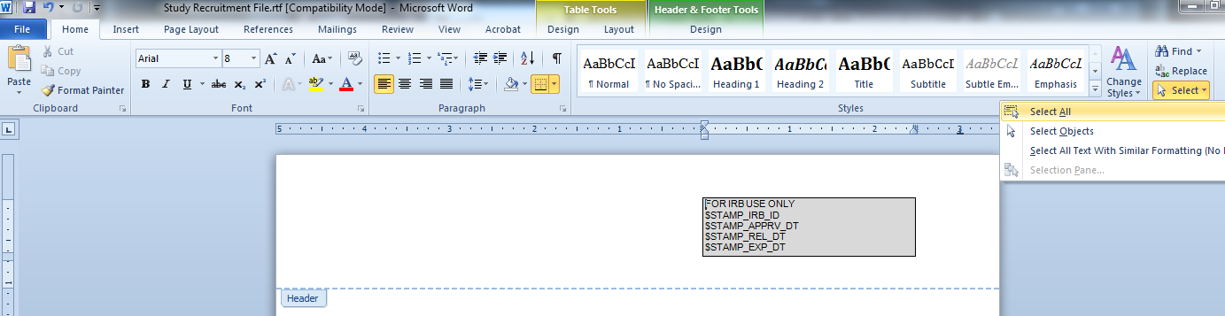
With the Home (B) tab selected in the Microsoft Word ribbon, click Select (C) then Select All (D).
C
B

D

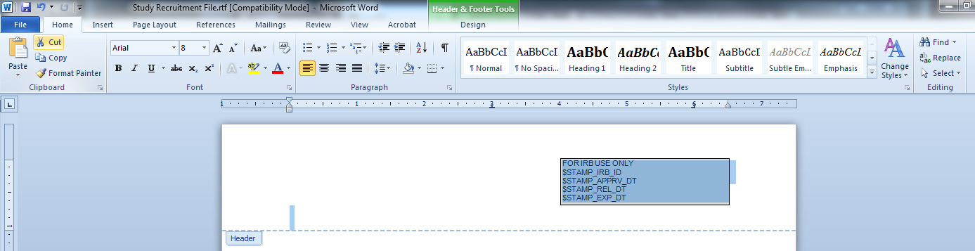
All contents of the header should now be highlighted. Choose Cut (E) from the Microsoft Word ribbon.
E

The header of the source file should now be blank.

- Copy a valid stamp.
Open myIRB and navigate to the form where the file needs to be attached (from the Draft Forms tab, click the title or from Inbox – To Do, click the To Do icon ). From the myProject index, click the myIRB link on the right to access the myIRB index (shown below). Use the Attachments button (F) to open the Attachment page.
F
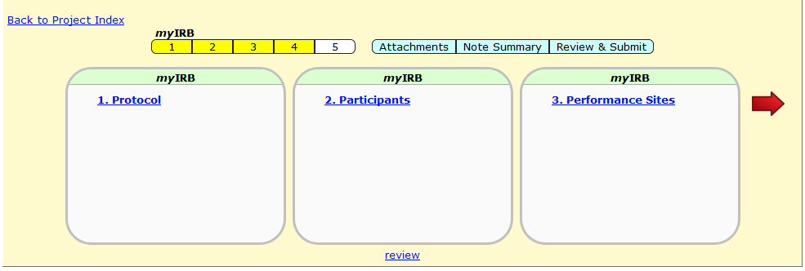

For consent templates, look below the category named “Consent/Assent Document and Information Sheets for Exempt Studies” for the dropdown menu and choose Blank document (G) then click Select Template (H).
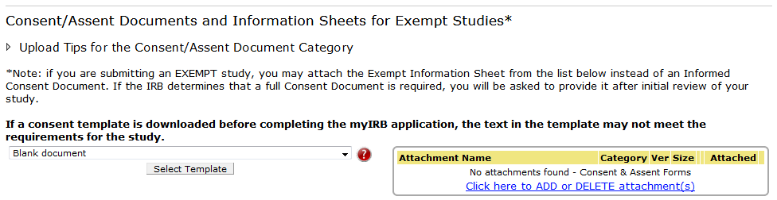
HH
G

For recruitment materials and debriefing statements, click the Generate Stamped Blank Template (I) button.
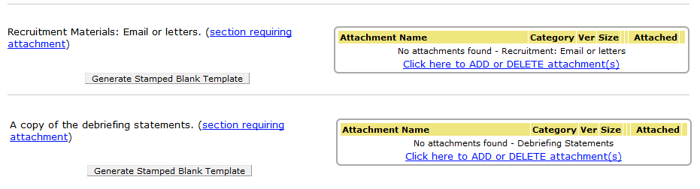

I

If prompted, choose the Open option (J) then click OK (K).
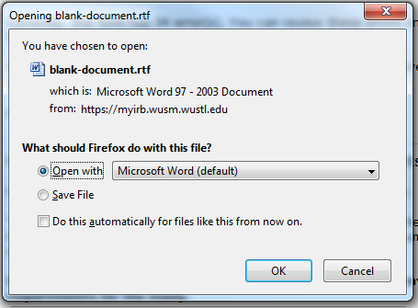
K
J

To open the header for editing, left click twice or right click once then click Edit Header (L) when it appears.
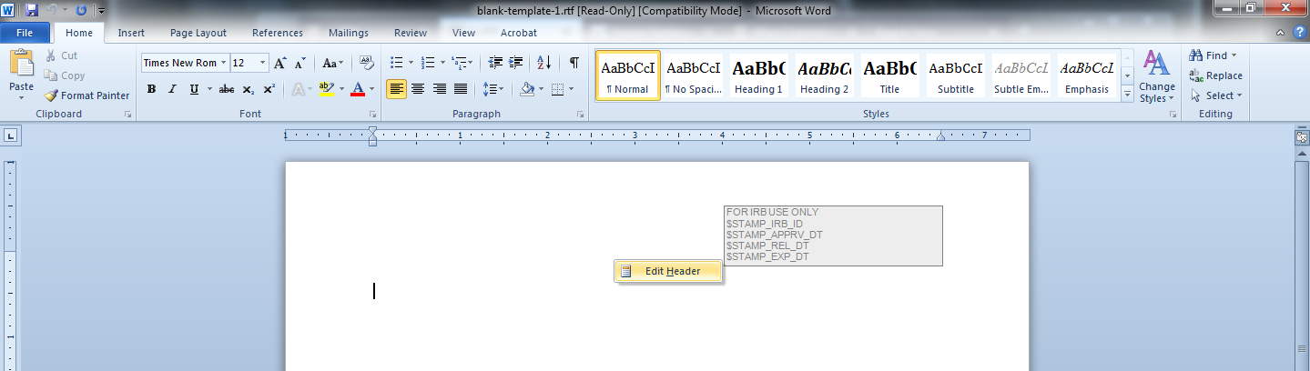
L

With the Home (M) tab selected in the Microsoft Word ribbon, click Select (N) then Select All (O).
M
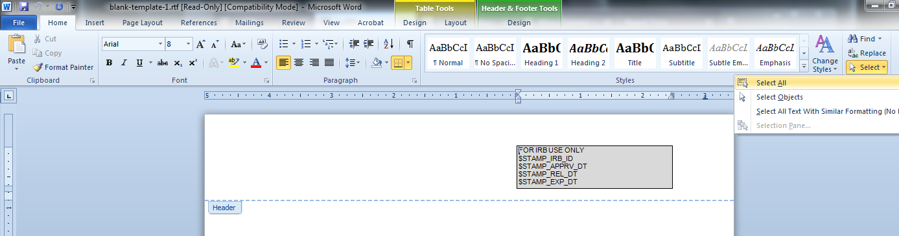
N
O

The stamp and all contents of the header should now be highlighted. Choose Copy (P) from the Microsoft Word ribbon.
P
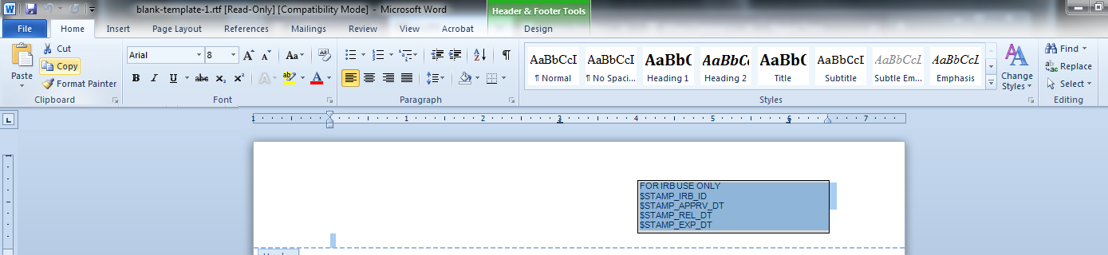

Return to your source file.

- Paste in the valid stamp.

Place your cursor in the header of your source file then select Paste (Q) from the Microsoft Word ribbon. Note: Click directly on Paste. Do not use the Paste Special options for picture, formatting, etc.
Q
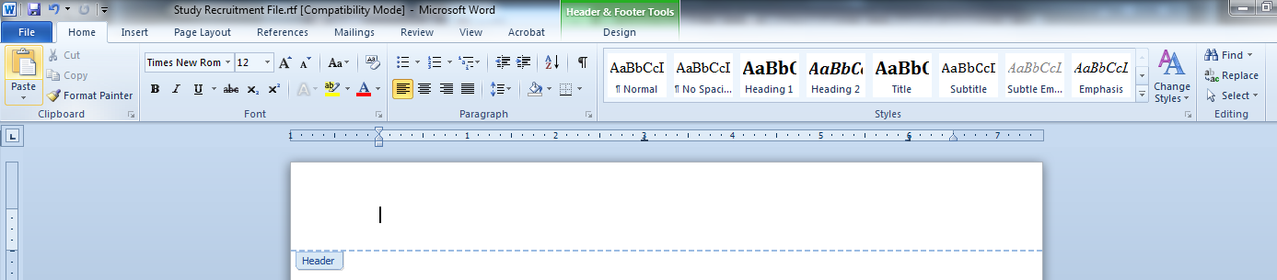

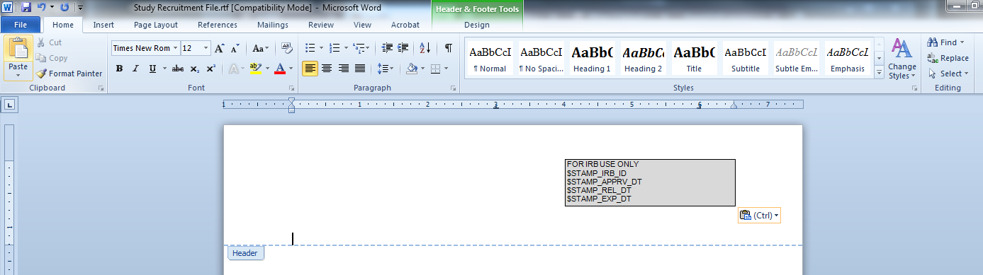
A valid stamp should now exist in the header of your source file.

Click any place outside the header to close it. When finished, save the file in rich text format (.rtf).

